Neonatal Oral Therapy

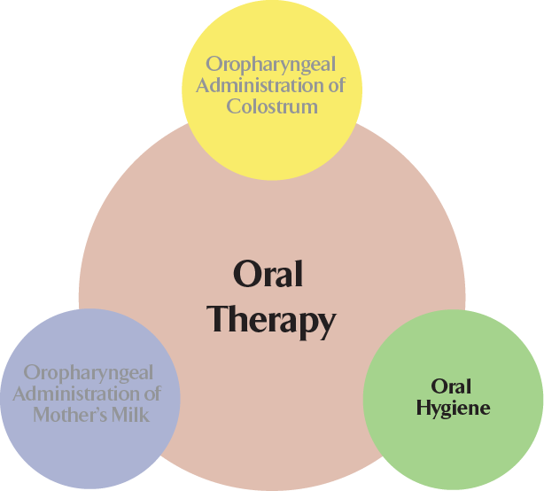

Plak-Vac® Petite Applicator Swabs
.
- Four sizes accommodate neonatal and pediatric use, 6, 8, 12 mm. and L.A. Swab
- Designed for cleaning and moisturizing the oral cavity.
- Ideal for hard-to-reach areas in the oral cavity, smaller patients, sensitive applications and those with limited oral access.
- Polyurethane foam head is soft, absorbent and will not lint or fray.
- Polypropylene swab handle is 6 inches in length for easy maneuverability.

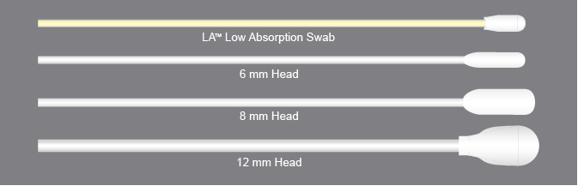

Our unique L.A. Low Absorption Swab was developed for applications wherein the loss
of oral therapy solution (e.g., colostrum) must be minimized. The Petite LA swab is size
appropriate for even the smallest babies and features a soft, non-shedding foam head that will not lint or fray when wet, and a smooth polypropylene handle rather than wood.

Plak-Vac® Petite Oral Therapy Kits

Plak-Vac Petite Oral Therapy Kits are custom-tailored to your unique oral care protocol. Designed to facilitate all oral care regimens to maximize protocol compliance while minimizing waste and cost. Plak-Vac petite applicator swab kits incorporate 6, 8 and 12 mm. petite swabs with mouth moisturizers or sterile water, and can be organized from simple single use swab kits to complete 24 hour point-of-care kits, and labeled with protocol instructions and hourly treatment times.
Colostrum Administration Kits also available with menu of components including sterile syringes to collect and administer the colostrum while maximizing dose delivery for oral mucosa absorption.

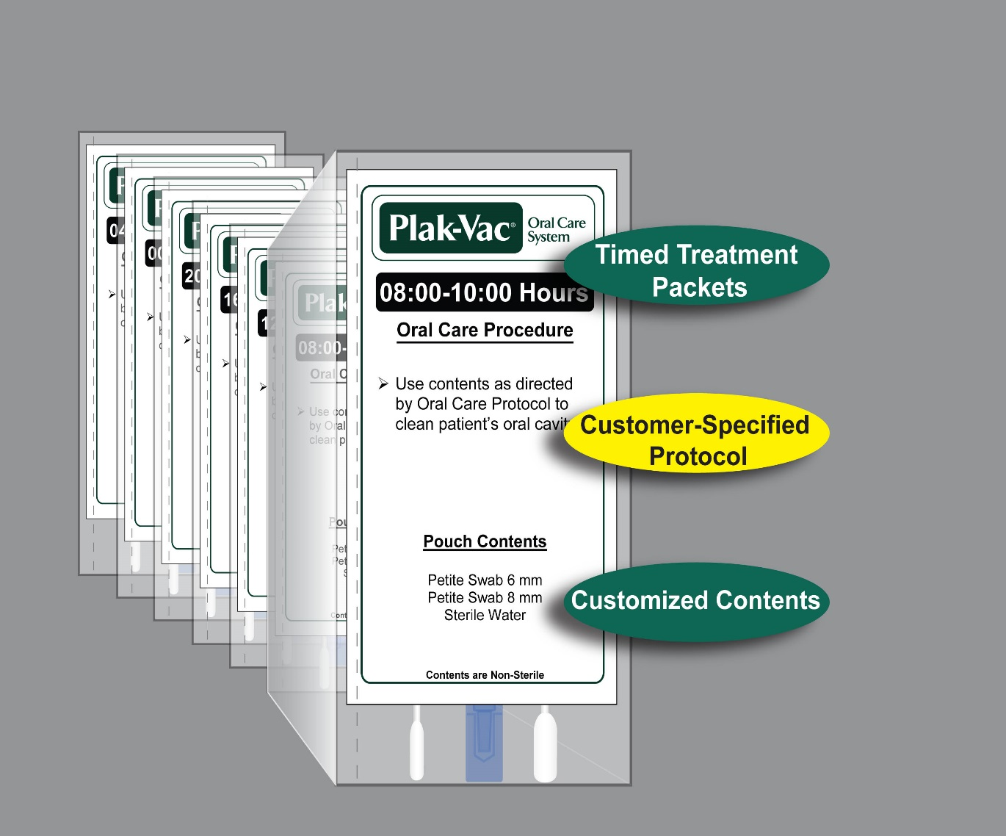
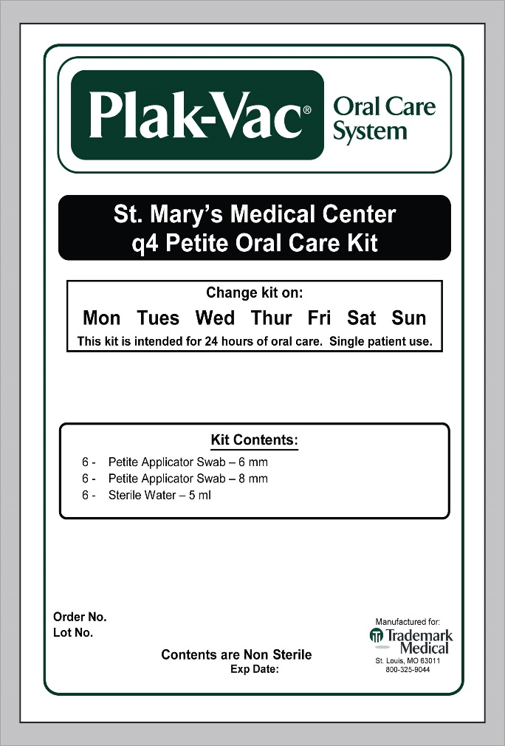

Flexible Menu of Kit Components reduces waste and cost while supporting protocol compliance

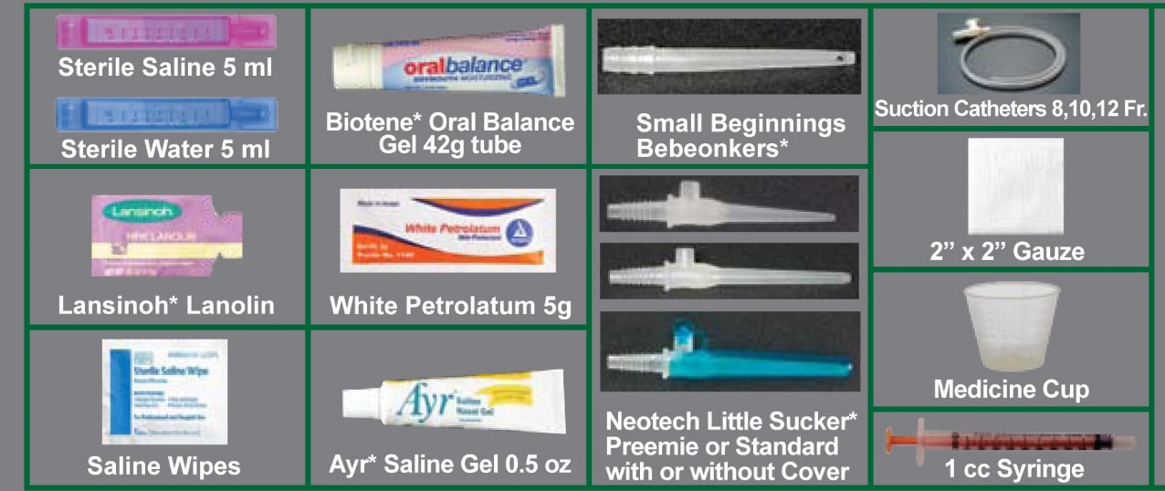

NOTE: NEED TO REMOVE BIOTENE TUBE PHOTO AND INSERT 15 ml. bioXtra

